

**BF 6-MONTHS INTERNSHIP  
(INTERNSHIP)**

**STUDENT INTERNSHIP REFLECTION REPORT**

**Name / Student ID**

# (Brendan) Lee Cheng Han S10239643A

**Company / Department / Role**

**China Galaxy Securities International Pte. Ltd. (Singapore)**

**Sustainability – ESG Product Intern**

**Word Count: 3,642**

Table of Contents

1. Introduction 1

2. On-the-Job Traning (OJT) Plan 1-2

3. Analysis & Reflection on Key Experiences 2-4

4. Accomplished Task / Noteworthy Achievement 4-6

5. Diversity & Inclusion 6

6. Influence of Internship on Future Plan 6-8

7.Conclusion 8-9

8.LinkedIn Profile 9

Appendices 10-17

Disclosure Statement for Use of Generative AI (Mandatory) 18-19

**1. Introduction**

The purpose of this internship reflection report is to document my learning experiences, professional development, and key takeaways from my 22-week internship at CGS International Securities (CGSI). This report will cover an overview of my responsibilities, achievements, challenges faced, and the impact of this internship on my future career aspirations. I will also reflect on how the NP Core Values (R3ICG – responsibility, resilience, respect, integrity, compassion, and gratitude) guided me throughout the internship.

CGSI is a leading financial services firm that focuses on securities trading, wealth management, and sustainability initiatives. As an intern in the Sustainability Department, I was responsible for tracking greenhouse gas (GHG) emissions, developing reporting templates, conducting ESG-related research, and contributing to corporate social responsibility (CSR) projects.

**2. On-the-Job Training (OJT) Plan**

At the start of my internship, I set several goals to enhance my technical knowledge, develop analytical skills, and improve project management capabilities. My key tasks and learning objectives included:

* GHG Tracking (Scope 1, 2 & 3): Updating power, water, and fuel consumption tracking lists for CGSI’s international operations.
* Developing an Excel template for Scope 1 & 2 emissions tracking: Creating a structured data collection and reporting system for sustainability services.
* ESG Research & Market Analysis: Conducting research on sustainability reporting regulations in ASEAN and China.
* Content Creation for the ASEAN Investment Challenge (AIC) 2024: Supporting TikTok content development and audience engagement.
* Sustainable Fashion Bazaar Project: Coordinating donation drives and event logistics in collaboration with stakeholders like RQAM & MINDS.

While I successfully achieved most of my goals, one challenge I encountered was fully mastering Scope 3 carbon accounting. Unlike Scope 1 and 2 emissions, which deal with direct and indirect energy-related emissions, Scope 3 covers a much broader range of indirect emissions across the value chain, making it significantly more complex.

The challenge stemmed from a few factors:

1. Data Availability & Quality: Many companies struggle to provide accurate and complete Scope 3 data, as it often involves gathering information from suppliers and external partners who may not have standardised reporting mechanisms.
2. The Complexity of Categories: Scope 3 emissions encompass 15 different categories, including business travel, employee commuting, purchased goods and services, and investments, each requiring unique quantification approaches.
3. Methodology Selection: To determine the most appropriate calculation methodology was another obstacle, as there are multiple accepted methods under the GHG Protocol (e.g., spend based, activity based, supplier specific data approaches), and selecting the right one depended on the availability and reliability of data.
4. Evolving Regulatory Landscape: ESG regulations regarding Scope 3 reporting are constantly evolving, and different jurisdictions/exchanges have varying requirements, further complicating compliance efforts.

To address these challenges, I took proactive steps:

* Self-Learning: I enrolled in LinkedIn Learning courses on GHG emissions reporting and studied GHG Protocol’s Scope 3 Calculation Guidance to better understand best practices in Scope 3 carbon quantification.
* Engaging with Experts: I actively reached out to sustainability professionals within CGSI and collaborated with PwC during our engagement to enhance my understanding of Scope 3 carbon accounting. Beyond this, I held frequent check in sessions with my mentor and colleagues who had greater expertise in carbon accounting. These discussions provided me with practical insights into Scope 3 quantification, helping me navigate the complexities of emissions tracking, data collection methodologies, and regulatory requirements. By leveraging both external expertise and internal mentorship, I was able to significantly improve my understanding of Scope 3 carbon accounting and its applications in corporate sustainability.

Through these efforts, I significantly improved my understanding of Scope 3 carbon accounting, particularly in navigating data collection complexities, stakeholder engagement, and methodology selection.

By coordinating with PwC and engaging with internal and external experts, I gained hands on experience in breaking down Scope 3 emissions into manageable components, understanding how different industries and jurisdictions approach reporting, and identifying best practices for accurate quantification.

**3. Analysis & Reflection on Key Experiences**

a) Solving a Challenge at Work

One of the most significant challenges I encountered during my internship was ensuring the accuracy and consistency of GHG emissions data collected from CGSI’s regional offices, namely Malaysia, Indonesia, Singapore (MIST), Thailand, Korea and United Kingdom. Each office followed different reporting standards, leading to inconsistencies in the data format, missing information, and varying measurement units. Initially, I assumed that standardising the format would be straightforward, but I quickly realised that different jurisdictions had their own regulatory frameworks and internal reporting constraints, making alignment difficult. Additionally, some offices had limited expertise in sustainability reporting, which further complicated the process.

To address this, I developed a data validation checklist, ensuring that all data submissions met specific quality criteria before integration. Using this, our team also conducted training sessions with regional teams, providing clear guidelines on how to track and report emissions accurately. While this solution improved data reliability, the process was more time consuming than expected, as I had to continuously liaise with different teams, answer clarifications, and revise the checklist to accommodate region specific constraints. Through this experience, I honed my problem-solving skills and learned the importance of patience and adaptability when working on large scale data projects. More importantly, I gained first hand exposure to how sustainability reporting operates across multinational corporations and the challenges businesses face when managing carbon disclosures globally. If I were to approach a similar challenge in the future, I would spend more time upfront understanding regional constraints and existing reporting practices before implementing a standardised approach.

b) Engaging with My Workplace Mentor

Working with my mentor, Kevin Lee, was one of the most impactful aspects of my internship. Coming from a banking and finance background, I had only surface level knowledge of sustainability and ESG products from my academic coursework. Kevin provided valuable insights on the intersection of sustainability and finance, guiding me on how ESG factors influence investment decisions, risk assessments, and corporate strategies. He emphasised that sustainability is not just about compliance and reporting, it is becoming a key driver of financial performance and long-term business resilience. This perspective helped me bridge my existing finance knowledge with real world ESG applications.

One of the key moments was during my involvement in the PwC x CGSI Climate Risk Engagement, where I was responsible for coordinating over 15 key stakeholders across MIST countries. Kevin advised me on how to structure climate risk discussions in a way that resonates with C-suite executives, ensuring that sustainability topics were framed in business terms rather than just technical ESG jargon. He also encouraged me to take a more active role in engagements, which led me to co-facilitate a breakout discussion session during the workshop with a few top decision makers. Initially, I was hesitant, as I felt I lacked the deep expertise to contribute meaningfully, but through Kevin’s guidance, I gained confidence in articulating climate risk concepts and ESG integration strategies.

Through regular check ins, I also had the opportunity to discuss career pathways in sustainable finance, learning about emerging roles such as ESG investment analysts, carbon risk consultants, and sustainability linked product specialists. These conversations helped me clarify my long-term career interests. Looking back, I realise that mentorship is a powerful tool for accelerated learning, and I now actively seek out experienced professionals in my network for insights and career guidance.

c) Networking with Industry Practitioners

Attending the Climate Risk Assessment Workshop (CGSI x PwC) was a defining experience in my internship, providing me with direct exposure to industry experts and sustainability professionals. I was particularly struck by the depth of knowledge these professionals had on climate risk modelling, ESG integration, and regulatory shifts, which highlighted how much more there was to learn beyond academic theories. The workshop discussions covered topics like climate stress testing for financial institutions, Scope 3 carbon disclosures, and sustainable investment strategies, all of which were areas I had minimal exposure to before my internship.

One of my biggest takeaways was understanding how ESG considerations are being integrated into investment portfolios and how climate risk is now a financial risk, not just an environmental concern. During the networking sessions, I had insightful conversations with PwC consultants and ESG analysts, who shared their perspectives on how sustainability frameworks like ISSB (International Sustainability Standards Board) and TCFD (Task Force on Climate-Related Financial Disclosures) are reshaping corporate financial disclosures. I also learned about the challenges businesses face in meeting sustainability compliance while ensuring profitability, which gave me a more balanced view of sustainability beyond the idealistic lens often portrayed in academic settings.

Despite the valuable insights, I realised that I could have been more proactive in networking. At first, I was hesitant to initiate conversations, feeling that I lacked the deep technical expertise to engage meaningfully. However, as the workshop progressed, I saw the value of asking insightful questions and showing curiosity rather than trying to showcase expertise. Going forward, I plan to approach industry events with a mindset of active learning and engagement, researching key discussion topics beforehand and setting personal goals for networking. I also intend to stay connected with professionals I met during the workshop, leveraging platforms like LinkedIn to maintain these relationships.

Overall, these experiences collectively shaped both my personal and professional growth, equipping me with new skills in problem-solving, stakeholder engagement, and industry networking. While I entered this internship with only a basic understanding of sustainability, I leave with a much deeper appreciation for the complexities of ESG integration in finance. More importantly, I have gained clarity on how I can contribute to this growing field, whether through sustainable investment analysis, climate risk advisory, or ESG driven financial product development.

**4. Accomplished Task / Noteworthy Achievement**

One of my most significant achievements during my internship was the development of an in house GHG Quantification Tool designed to support CGSI’s advisory services. The objective was to create a robust system that enables corporate clients to accurately measure their carbon footprint and gain insights into their climate risk exposures. I began by analysing the gaps in our existing data reporting systems and identifying the need for a tool that could integrate various data sources, standardise emissions calculations, and provide clear outputs aligned with global sustainability standards such as United States Environmental Protection Agency (USPEA), GHG Protocol and Intergovernmental Panel on Climate Change (IPCC). Using a combination of advanced Excel functions and stakeholder feedback. I developed a tool that not only streamlined the data collection process but also enabled real time analysis of carbon emissions across Scope 1, 2, and even preliminary Scope 3 categories.

The impact on the business was multifaceted. The tool significantly enhanced our ability to deliver data driven carbon advisory services by providing clients with a clear and comprehensive picture of their emissions profile. This, in turn, allowed them to pinpoint key areas for decarbonisation, ultimately strengthening their commitment to sustainability. Feedback from my supervisor was particularly encouraging—he praised the practical application of the tool, noting that it added tangible value to the firm’s sustainability services. A coworker also highlighted how the tool had bolstered CGSI’s capacity to assist clients in prioritising emission reduction strategies, marking it as a crucial step forward in our sustainability initiatives.

In reflecting on this project, I realised how my classroom learning laid the groundwork for this achievement. Courses in finance and data analytics equipped me with the technical skills needed for complex data manipulation and statistical analysis, while introductory modules on sustainability and its risks provided the conceptual framework for understanding carbon accounting. These academic insights, combined with hands on training in carbon reporting standards like the GHG Protocol, proved invaluable. I was able to apply theoretical knowledge to real world challenges, bridging the gap between abstract concepts and practical application.

Throughout the development process, I acquired new skills that extended beyond traditional classroom teachings. I honed my project management abilities by coordinating with different departments and external consultants, namely PwC, to ensure that the tool met both technical and business requirements. I also enhanced my problem-solving and critical thinking skills, especially when faced with the complexities of standardising data from multiple sources. This project not only deepened my understanding of GHG emissions quantification methodologies but also reinforced my commitment to pursuing a career at the intersection of finance and sustainability.

If I were to undertake this project again, I would place a stronger emphasis on rigorous data testing by comparing the tool’s outputs with audited sustainability report data from comparable companies. I would conduct extensive cross validation to determine if the calculated emissions match verified figures and, if discrepancies exist, quantify the percentage difference and investigate the causes. For example, if I discover that the emission factors data bank in the Excel sheet is outdated or inaccurate, I would cross check these values against current global standards and industry benchmarks, adjusting them as necessary. Engaging end users earlier in the design phase would also be a priority, allowing for more intuitive interface improvements and greater customisation to meet specific client needs. This iterative process combining advanced automation and data visualisation techniques (potentially using Python) with continuous professional development in sustainable finance and software development would ensure that the tool remains both highly accurate and scalable, thereby better serving our clients in their decarbonisation efforts.

Overall, this achievement not only demonstrated my ability to leverage both academic knowledge and practical skills but also significantly contributed to CGSI’s strategic initiatives in sustainability and climate risk management.

**5. Diversity & Inclusion**

During my internship, I had the opportunity to work closely with a university intern from China who was majoring in Biodiversity Conservation and Sustainability at NUS. She joined the team shortly after I started my 22-week internship, and while we shared a common goal of advancing sustainability initiatives, we initially faced a language barrier. She primarily conversed in Chinese, while I mainly spoke English, and despite being ethnically Chinese, my proficiency in the language was limited. However, we adapted by using tools like Google Translate and ChatGPT to facilitate communication, and over time, we naturally improved in each other’s languages she became more confident in English, and I started picking up more Chinese vocabulary relevant to our work.

Our collaboration was highly complementary, she had strong subject matter knowledge in biodiversity and carbon management, while I contributed financial expertise. She assisted me with research on emissions factors for the GHG calculator tool, ensuring its scientific accuracy, while I supported her in understanding the financial viability of carbon projects, performing discounted cash flow (DCF) analyses of companies, and refining the finance section of her pitch deck. Through this exchange, I gained a deeper appreciation for how scientific and financial perspectives must align for sustainability initiatives to be both environmentally and economically viable.

This experience reshaped my understanding of effective teamwork in a diverse workplace. I learned that cultural and disciplinary differences, rather than being barriers, can be leveraged to enhance problem-solving. By adapting my communication approach, using visual aids, structured discussions, and written clarifications, I was able to foster clarity and collaboration. More importantly, I realised that patience, active listening, and openness to different perspectives lead to more well-rounded decision making. Moving forward, I will continue to embrace diverse viewpoints, recognising that they strengthen both individual learning and collective success.

**6. Influence of Internship on Future Plan**

This internship has been an eye opening experience, providing me with firsthand exposure to the intersection of finance and sustainability. I initially chose to explore sustainability because it was a hot topic and an emerging field within finance, and I was genuinely curious about the opportunities in sustainable finance. However, as I reflect on my time at CGSI, I realise that while sustainability is here to stay, my long-term career path remains open-ended. Will I continue to pursue sustainable finance? The honest answer is—who knows? Finance is a constantly evolving industry where market needs, regulations, and career opportunities can shift overnight. With two years of national service ahead and another three to four years in university, my career aspirations may develop further. While I will continue to monitor the sustainability space, I also recognise the value of staying flexible and adaptable to emerging opportunities in finance.

Strengths and Areas for Development

One of my greatest strengths gained from this internship is my ability to analyse sustainability related financial data and integrate it into broader financial strategies. Through projects such as developing the GHG Quantification Tool, I have enhanced my analytical thinking, problem-solving, and data interpretation skills, which are critical in both sustainable finance and traditional financial roles. Additionally, my experience collaborating across departments has strengthened my cross functional teamwork and adaptability, essential skills in the ever-changing financial industry.

However, I recognise that there are areas I need to develop further to stay competitive in both traditional finance and ESG related fields. One key area is Scope 3 carbon accounting, which remains a challenge due to the complexity of supply chain emissions. Mastering Scope 3 calculations will be essential for assessing the full carbon footprint of businesses and investment portfolios. Additionally, I aim to deepen my understanding of sustainable finance products, such as green bonds, sustainability linked loans, and impact investing, which are becoming increasingly important in shaping the future of finance.

Action Plan for Continuous Development

To ensure that I continue growing as a finance professional in an evolving landscape, I have outlined key actions that will help me stay adaptable and competitive in the industry:

* Expand My Financial and ESG Knowledge: While I may not specialise in sustainable finance, I recognise that ESG considerations are becoming a key part of investment and risk management decisions. To stay ahead, I plan to pursue certifications such as CFA ESG Investing or SASB Fundamentals of Sustainability Accounting (FSA) to develop a structured understanding of how sustainability integrates with finance.
* Stay Updated on Industry Trends: With regulatory changes happening rapidly in the sustainability space, I will actively follow updates from key organisations such as the ISSB, TCFD, and the EU Sustainable Finance Disclosure Regulation (SFDR). Additionally, I will continue reading industry reports and research on climate risk assessment, carbon markets, and green finance innovations.
* Develop a Broad Skill Set in Finance: Whether I continue in sustainable finance or explore other finance related paths, I want to build a strong foundation in investment principles, corporate finance, and risk management. I will take advantage of university courses, self-learning platforms, and internships to gain hands on experience in financial modelling, valuation techniques, and portfolio management.
* Expand My Professional Network: Networking has played a valuable role in broadening my industry perspectives during my internship, and I intend to continue engaging with ESG professionals, investment analysts, and corporate finance experts. I plan to attend finance and sustainability conferences, participate in webinars, and actively engage with professionals on LinkedIn to stay connected with industry developments.

While my exact career path remains undecided, this internship has given me a strong foundation in sustainable finance and financial analysis, which will be valuable regardless of where I specialise. The knowledge and skills I have gained will allow me to adapt to industry trends and position myself for opportunities in investment banking, financial consulting, or sustainability focused roles. Whether or not I continue down the sustainable finance path, I am confident that my experience at CGSI has prepared me to navigate an industry where sustainability considerations will continue to grow in importance.

**7. Conclusion**

My internship at CGSI has been an enriching and transformative experience, providing me with real world exposure to sustainability within the financial sector. Coming from a banking and finance background, I initially had only a surface level understanding of ESG and sustainability, but this internship has allowed me to bridge that gap by applying my knowledge in carbon accounting, sustainable finance, and corporate sustainability strategy. Over the past year, I have developed stronger analytical skills, problem-solving abilities, and project management expertise, all of which will be invaluable as I continue my professional journey. Beyond technical skills, I have also grown personally, learning how to adapt to new challenges, communicate effectively across diverse teams, and approach sustainability from a broader business perspective.

Looking ahead, I plan to continue exploring sustainable finance while remaining open to new opportunities within the finance industry. Regardless of where my career path takes me, I know that sustainability will remain an integral part of financial decision making, and the knowledge I have gained during this internship will serve me well in navigating the evolving landscape of ESG regulations, carbon markets, and responsible investing. This experience has reaffirmed my belief that finance can be a powerful tool for driving positive environmental and social impact, and I am eager to continue building my expertise in this field.

I am deeply grateful to CGSI for providing me with this opportunity to learn, grow, and contribute. I would like to sincerely thank my mentor, Kevin Lee, for his invaluable guidance and industry insights, which have greatly shaped my understanding of sustainability in finance. I also extend my gratitude to my boss and colleagues, who have been incredibly supportive, patient, and generous in sharing their knowledge and experiences. Working alongside other interns from diverse backgrounds has also been an eye-opening experience, as we learned from each other and collaborated on impactful projects together. Most importantly, I want to express my appreciation to my school internship supervisor, who continuously checked in with us to ensure that we were maximising our learning experience. Her encouragement, thoughtful discussions, and reflective exercises pushed us to think critically about our growth, challenge ourselves, and make the most of this internship.

As I move forward, I will carry these lessons, experiences, and connections with me. This internship has given me a solid foundation, and I am excited to see how my career unfolds in the years to come. Thank you once again to everyone who has been part of this incredible journey.

**8. LinkedIn Profile**

<https://www.linkedin.com/in/brendan-lee-cheng-han/>

Word Count (inclusive of headers and brackets): 3,642 Words

**Appendices**

Appendix 1 – Work Life

1.1

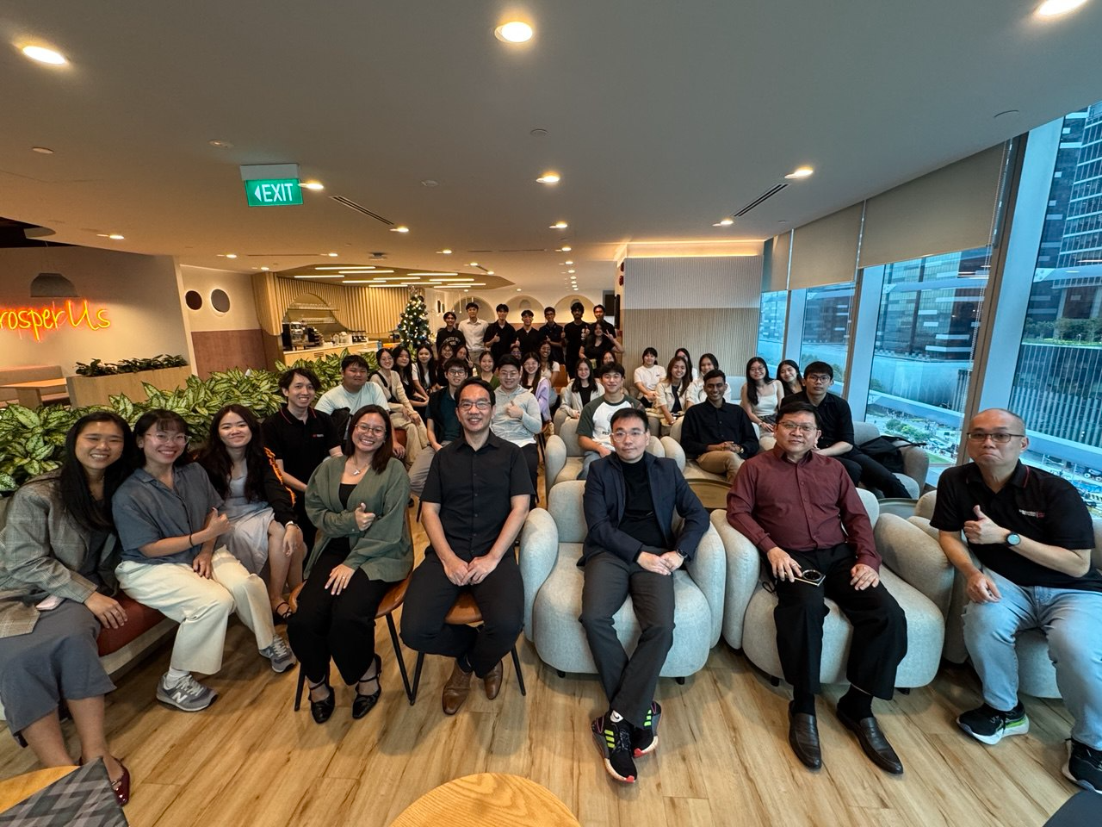

1.2

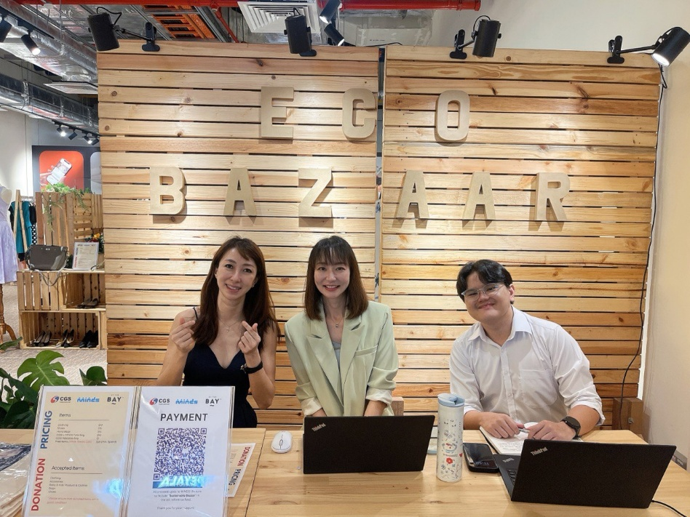

1.3

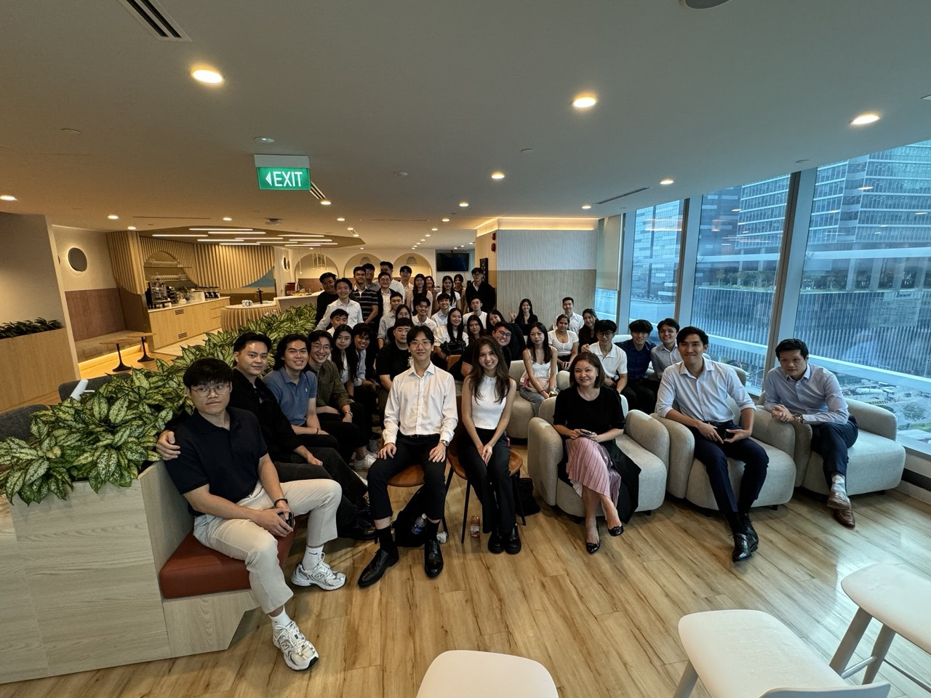

1.4

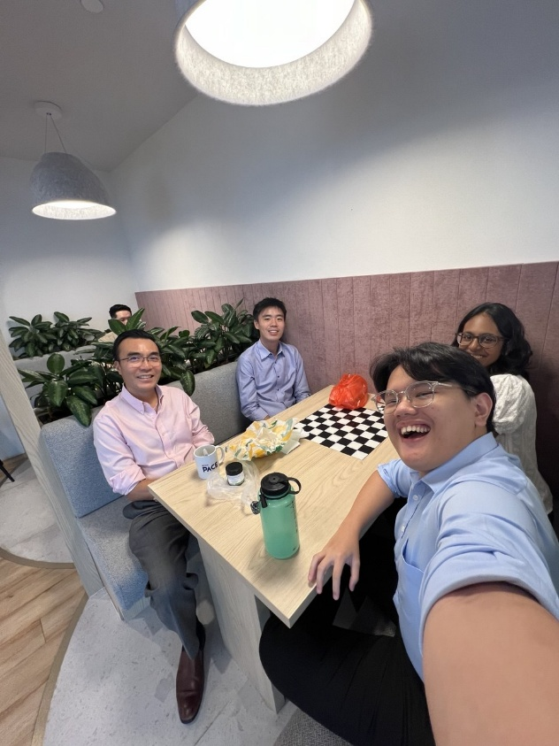

1.5

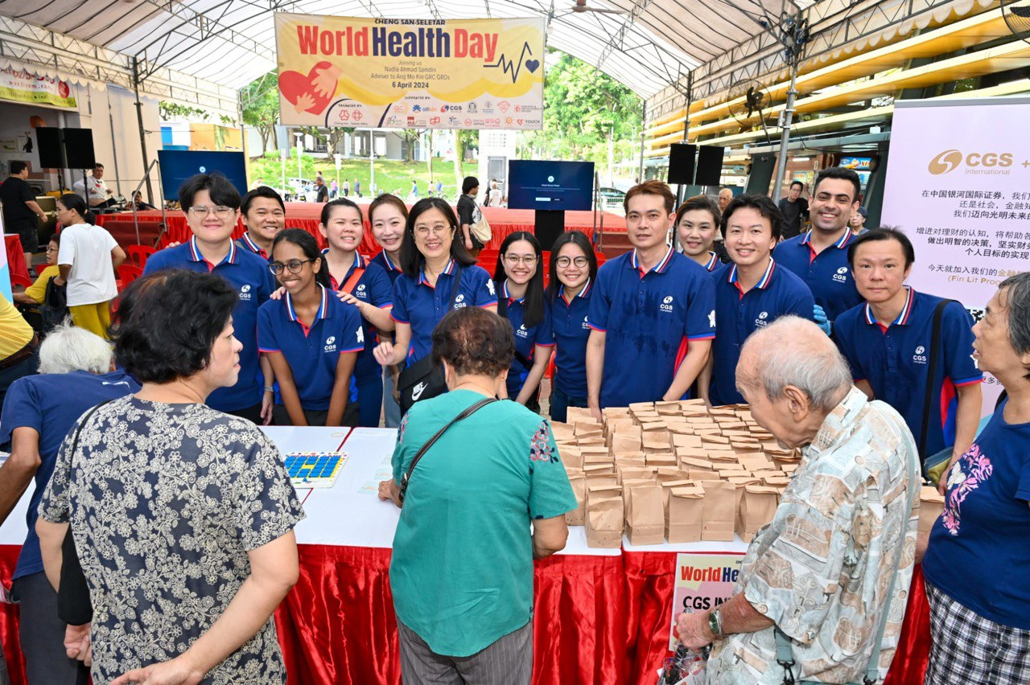

1.6

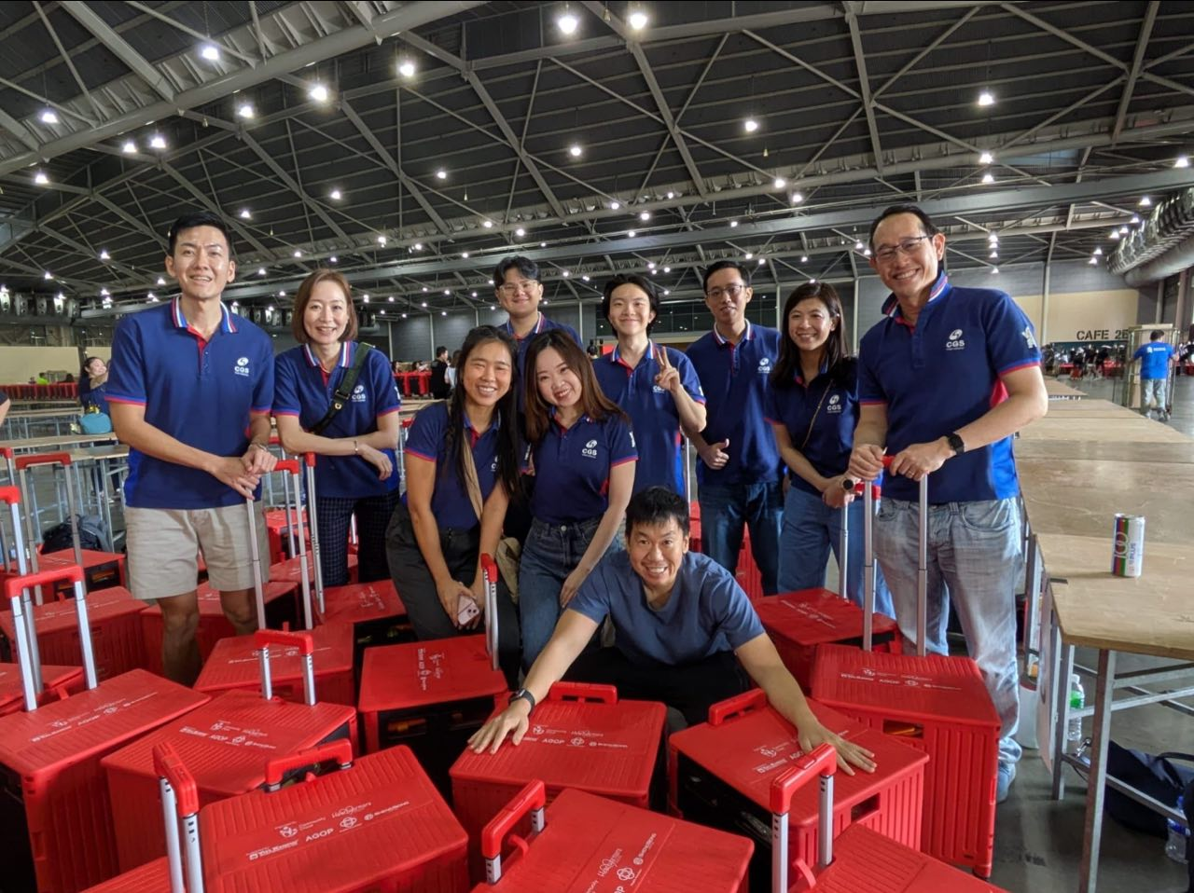

Appendix 2 – Work Projects

2.1 – Example of Emission Factor ‘Blackbox’ in the Carbon Calculator Tool

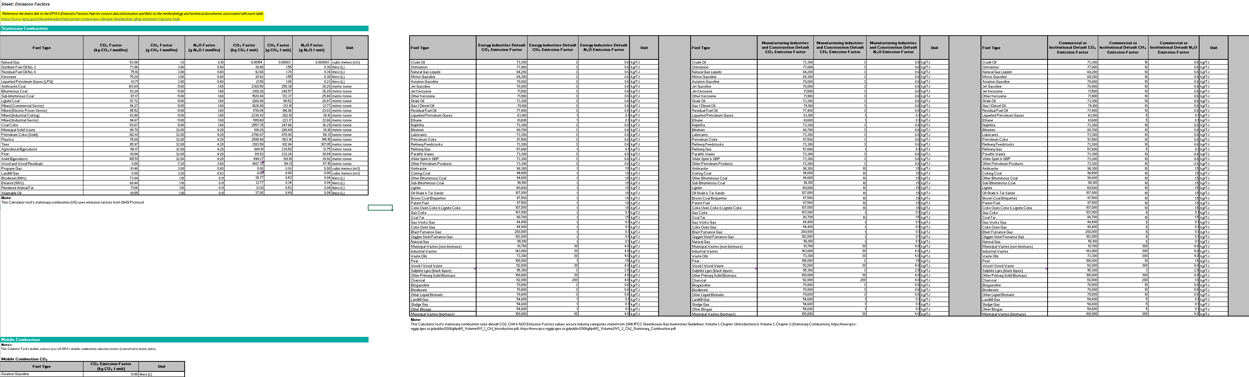

2.2 – Example of Scope 1 data collection sheet (using data validation)

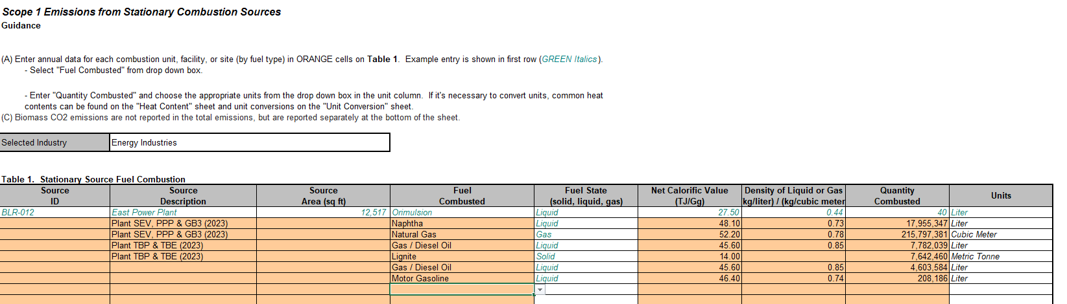

2.3 – List of reference documents for the calculator tool

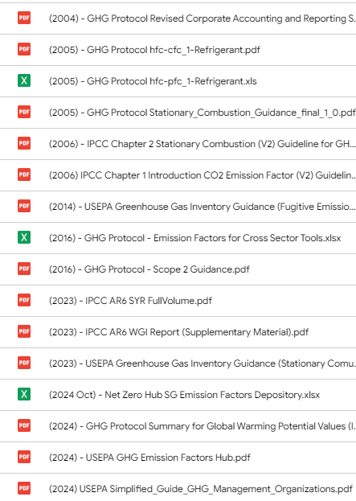

2.4 – Example of GHG Emission Data Sheets for MIST,UK & Kr countries

(not cleared to show real sheet)

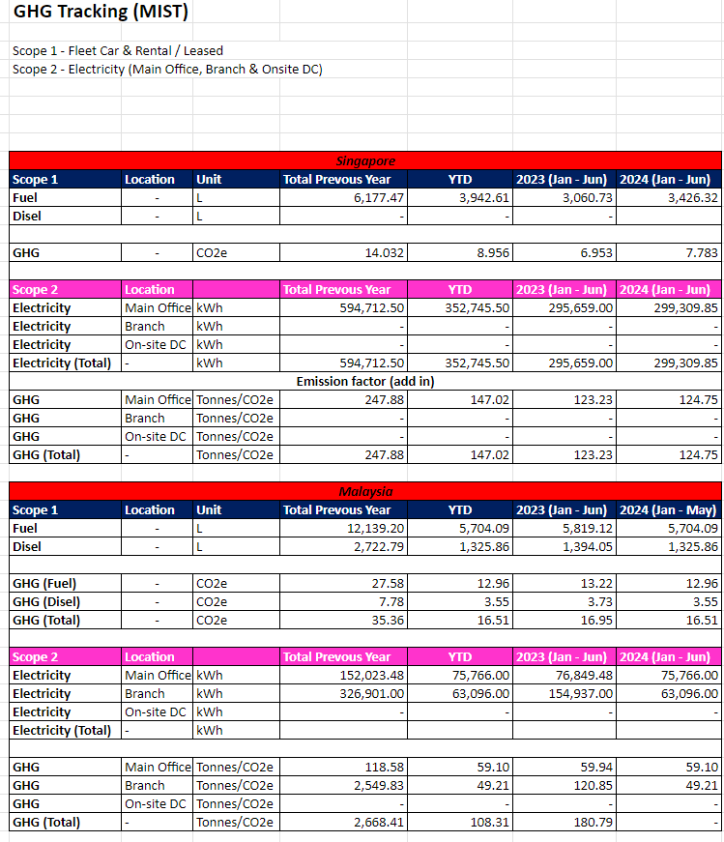

2.5 – Example of PwC x CGSI Engagement (climate Risk Assessment Workshop) Slides

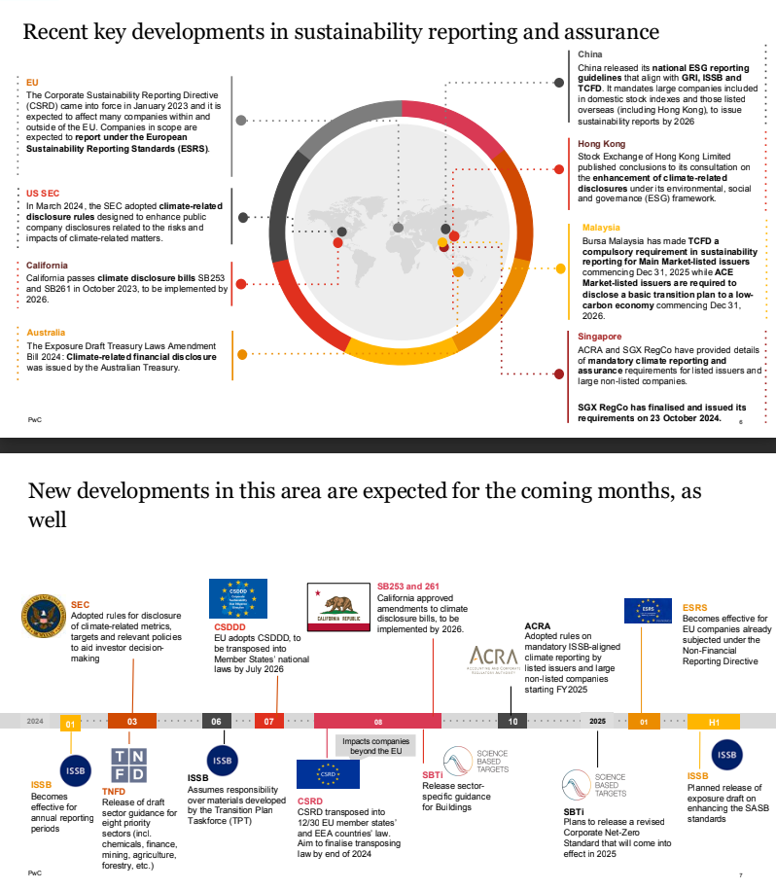

2.6 – Final Taxonomy from engaging with PwC on our company stakeholders

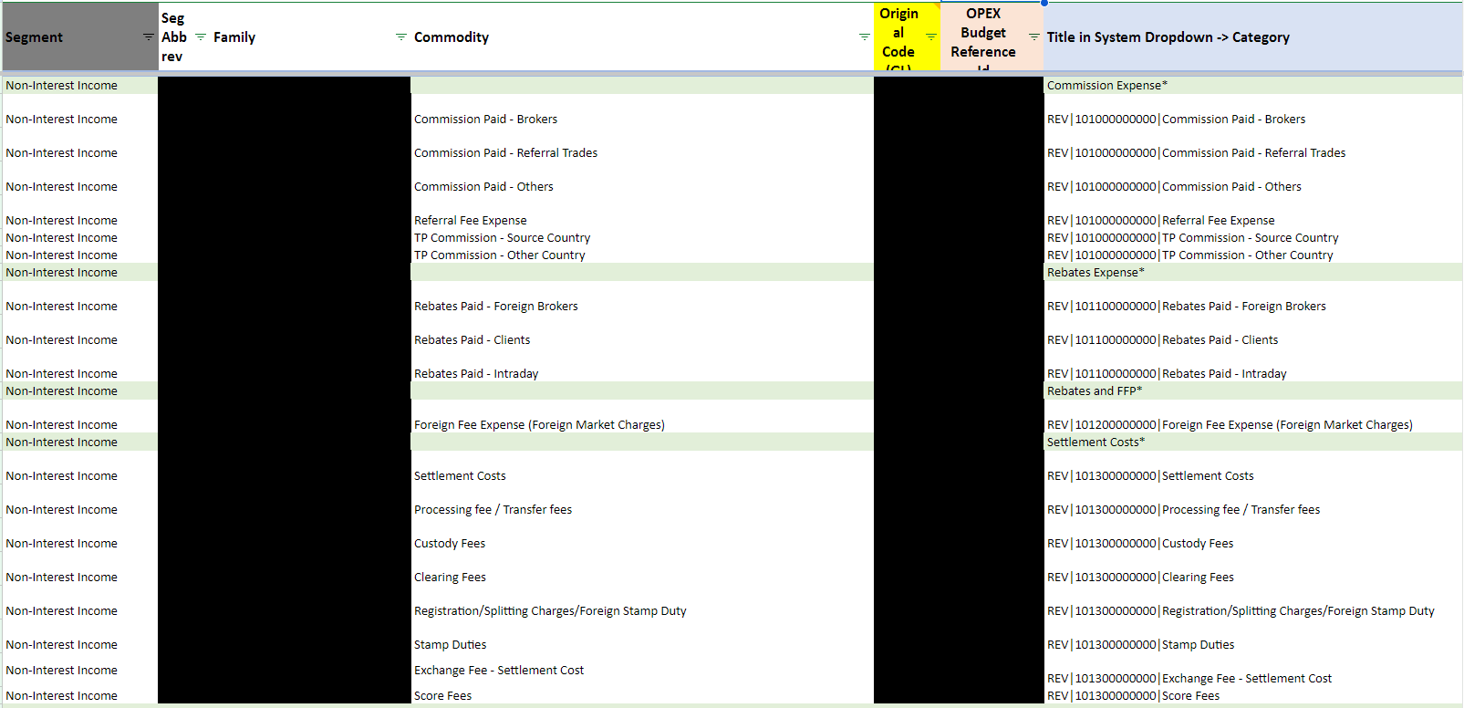

2.7 – Example of ESG Rating Agencies Research

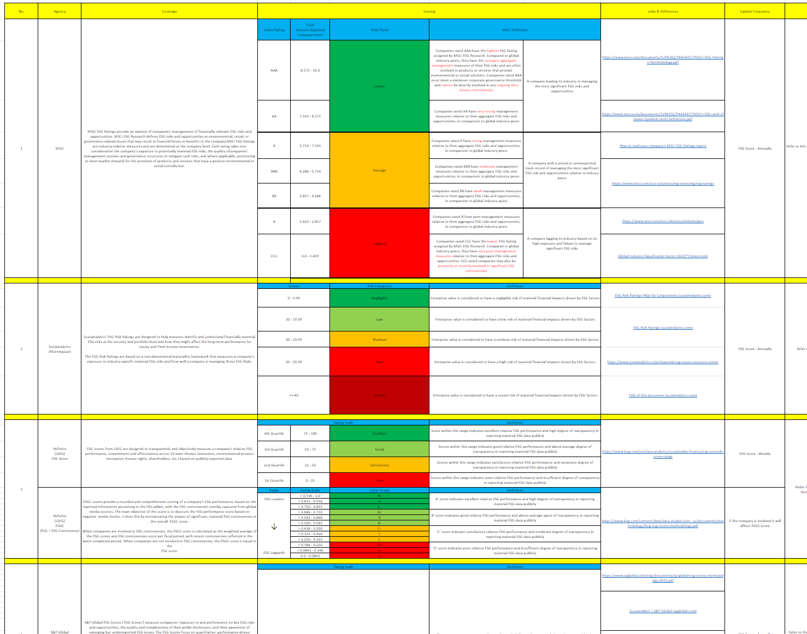

2.8 – Example of ASEAN Exchanges Sustainability Reporting Requirements - Comparative Tables Research

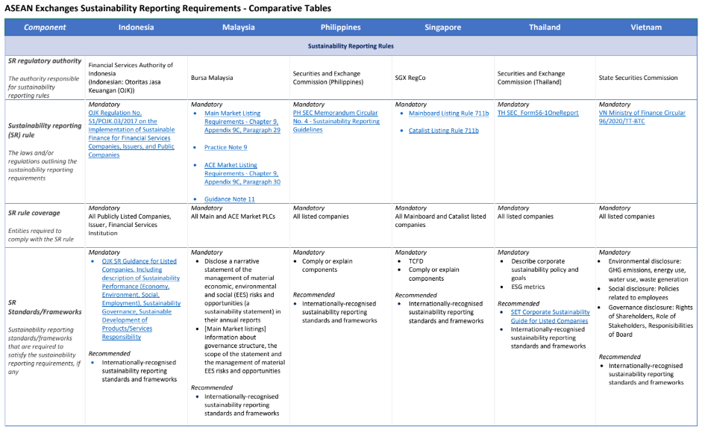

ASEAN Exchanges. (2023). *AEx SR table_final_0*. <https://cdn-asset.aseanexchanges.org/wp-content/uploads/2023/04/AEx-SR-table_final_0.pdf>

Appendix 3 – Testimonial

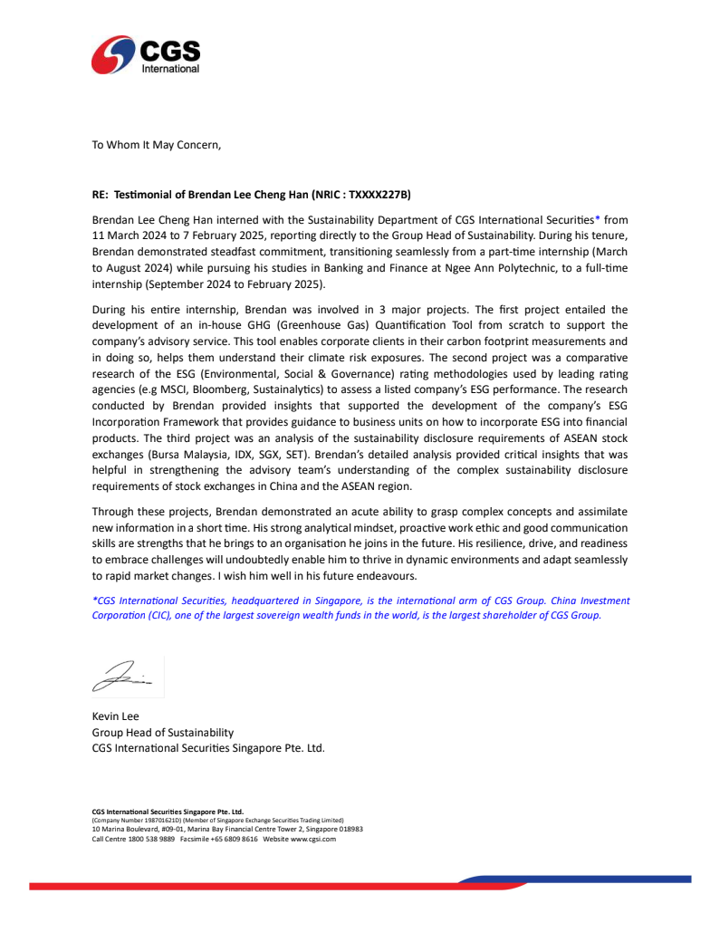

# Disclosure Statement for Use of Generative AI (Mandatory)

Part 1

[Put an “X” in the appropriate box(es) below]

|  |  |
| --- | --- |
|  | I/ We declare that no generative AI tool has been used in this assessment. [End of declaration] |
| X | I/ We declare that generative AI tools have been used in this assessment. [Continue to Part 2, Part 3 and Part 4 below] |

Part 2

Specify the generative AI tools used and the respective purposes.

|  |  |  |  |  |
| --- | --- | --- | --- | --- |
|  | | **Generate materials for background research**  Note: Materials produced by generative AI tools need to be referenced to avoid plagiarism  [Put an “X” in the appropriate box(es) below] | **Improve the academic tone and accuracy of language, including grammatical structures, punctuation and vocabulary**  [Put an “X” in the appropriate box(es) below] | **Others**  [Specify use below] |
| ChatGPT | | X | X |  |
| Grammarly | |  |  |  |
| GrammarlyGO | |  |  |  |
| Marmof | |  |  |  |
| QuillBot | |  | X |  |
| [Specify name of technology] |  |  |  |  |
|  |  |  |  |
|  |  |  |  |
|  |  |  |  |
|  |  |  |  |

Part 3

List the prompts used in the generative AI tools

|  |  |
| --- | --- |
| **Generative AI Tool** | **Prompt** |
| ChatGPT | Can you help me improve my report’s conclusion based on what has been already written? |
| ChatGPT | Can you help me rephrase this (report – professional)? |
| ChatGPT | Can you help me rephrase this (report – professional)? |
| ChatGPT | Can you help me rephrase this (report – professional)? |
| ChatGPT | Can you help me rephrase this (report – professional)? |
| ChatGPT | Can you help me rephrase this (report – professional)? |
| ChatGPT | Can you help me rephrase this (report – professional)? |
| ChatGPT | Based on this entire paragraph does it hit the criteria? |
| ChatGPT | Based on this entire paragraph does it hit the criteria? |
| ChatGPT | Based on this entire paragraph does it hit the criteria? |
| ChatGPT | Can you help me improve the critical analysis portion? |
| ChatGPT | Based on this, can you help me rephrase this and place it in a concise manner? |
| QuillBot | Changing language for paragraphs |
| QuillBot | Changing language for paragraphs |
| QuillBot | Changing language for paragraphs |

Part 4

[Put an “X” in the box below]

I/ We acknowledge that I/ we have checked and verified the output of the generative AI tools.

I/ We acknowledge that I/ we have adapted and modified the output of the generative AI tools for this assessment.

I/ We acknowledge that the following records will be kept and may be requested from me/ us.

* Drafts of work before/ during use of the generative AI tools
* History of use of generative AI tools for this assessment

Disclosure Statement adapted from [https://www.monash.edu/student-academic-success/build-digital-](https://www.monash.edu/student-academic-success/build-digital-capabilities/create-online/acknowledging-the-use-of-generative-artificial-intelligence) [capabilities/create-online/acknowledging-the-use-of-generative-artificial-intelligence](https://www.monash.edu/student-academic-success/build-digital-capabilities/create-online/acknowledging-the-use-of-generative-artificial-intelligence) and [https://vascular.org/vascular-specialists/research/journals/declaration-generative-ai-scientific-writing.](https://vascular.org/vascular-specialists/research/journals/declaration-generative-ai-scientific-writing)